1. Estimate your dosage based on your body weight
As with most substances, individuals with more body mass will require more CBD to experience its effects. With that being said, a good rule of thumb to determine your proper CBD dosage is to take 1–6MG of CBD for every 10 pounds of body weight based on the individual’s level of pain or other symptoms.
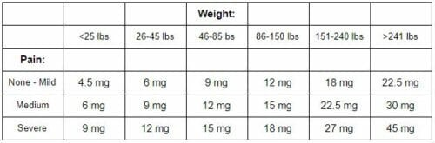

2. Start small and increase gradually
it is important to first determine your initial dosage based on your weight, gauge how your body reacted to that amount of CBD, then increase gradually while continuing to monitor your body’s reactions till you find the perfect dosage that works for your situation. Simply fill the dropper, administer the oil under your tongue, then hold it there for 30 to 90 seconds before swallowing.
But, how many drops of CBD oil should you take? With some simple mathematics, we can easily figure that out. Being that the dropper is the tool we use to administer a CBD tincture, we need to find out how much CBD is in a single dropper. Once you know this, you can gauge how much CBD you’re taking.
So how do you figure out how much CBD is in a dropper?
Typically, a dropper holds 1 ML of liquid. If you know how many milliliters are in a CBD tincture, you can use this simple formula to determine how much CBD is in its dropper:
[Total CBD in Bottle] ÷ [Number of Milliliters in Bottle] = MGs of CBD in a Dropper
3000 ÷ 30 = 100MG of CBD per dropper
1500 ÷ 30 = 50MG of CBD per dropper
1000 ÷ 30 = 33.3 MG of CBD per dropper
500 ÷ 30 = 16.6 MG of CBD per dropper
250 ÷ 30 = 8.3 MG of CBD per dropper
Now, if you’re proper dosage of CBD is 25MG, and a single dropper of that 1500MG tincture contains 50MG, you’d simply fill the dropper halfway.
How to take: Write down the severity of your symptoms on a scale of 1-10. Then start out with ½ dropper at bedtime and 1/2 dropper in a.m. It will help you sleep too. On the 4th day, rate your symptoms on a scale of 1-10. If you’re not at a 1 or 2 the take a full dropper in the a.m. and p.m. After a week rate your symptoms. You can increase the oil dose until you notice a difference. However after some weeks/months you might be able to lower your dose for maintenance. You can also have someone massage the oil on your pain points.

